

Department | FED
Subject | DSA-2
Academic Year | Ⅰ-Ⅲ Semester(2025-26)
Faculty Name | Ms. Alluri Swathi
Student Name | Boddapati Himavanth Sai Ganesh
Roll Number | 2520030429
Branch | CSE
Course Outcome | 2

Case Study Topic: EduGraph Learning Analytics System using B+ Tree & Segment Tree

Work Done Summary:
The application of B+ Trees and Segment Trees in managing educational analytics and database indexing efficiently. An EduGraph Learning Analytics System was developed where student performance records are stored, indexed, searched, and analyzed using advanced tree data structures.

Implementation Details:
- Created B+ Tree Node classes with fields: studentId, studentName, courseName, score, keys, and children.
- insert() method stores student performance records efficiently in the B+ Tree.
- search() method retrieves student details quickly using Student ID.
- displayRecords() module prints all student performance records in sorted order.
- Implemented Segment Tree structure for efficient range query operations.
- buildSegmentTree() method constructs the Segment Tree from score arrays.
- rangeQuery() method calculates total and average scores within a specific range.
- updateScore() method updates student scores dynamically in the Segment Tree.
- comparePerformance() analyzes efficiency between normal array traversal and Segment Tree queries.
- Main method demonstrated record insertion, searching, range sum queries, score updates, and performance analysis.
- Performance comparison for adaptive course recommendation.

Result: Screenshots/Output
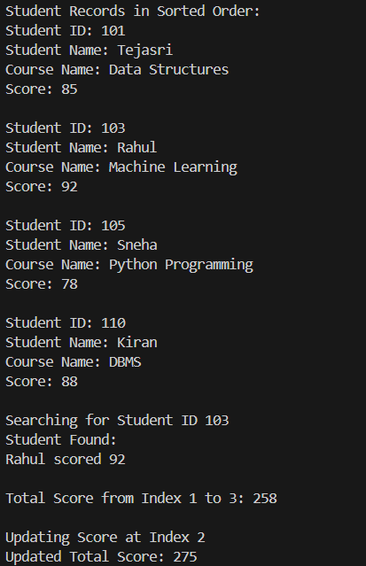
- Successfully inserted and indexed student records using B+ Tree.
- Faster retrieval of student performance data observed.
- Segment Tree efficiently calculated range-based score analytics.
- Dynamic score updates performed successfully.
- Sorted student records generated through traversal operations.

Time Complexity Analysis
• B+ Tree Insert/Search/Delete: O(log n)
• Segment Tree Build: O(n)
• Segment Tree Range Query: O(log n)
• Segment Tree Update: O(log n)
• Compared to traditional array traversal O(n), Segment Trees provide faster interval queries and efficient analytics for large-scale educational systems.

GitHub Link: https://github.com/himavanthsaiganesh/DSA2-CASE-STUDY-CO---2

Student Signature | Faculty Signature

